Stakeholder Report
Justin Gay
Predictive Analytics
Professor Scott Turner
December 8th, 2025

Financial Analysis Summary Report

Executive Summary
This report summarizes insights from clustering and predictive modeling on financial data. Four meaningful clusters were identified, showing different revenue and profitability patterns. A Random Forest model accurately predicted high‑margin firms, and the cluster feature improved performance. This report is intentionally brief (2–3 pages) and includes only the essential visuals.

Feature Discovery (Clustering)
K-Means clustering was applied to standardized financial features. The elbow and silhouette plots supported selecting k = 4 clusters.
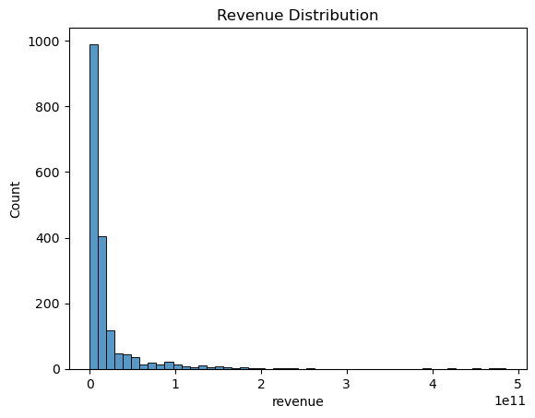
Figure 1. Elbow Plot — the curve begins flattening around k = 4.
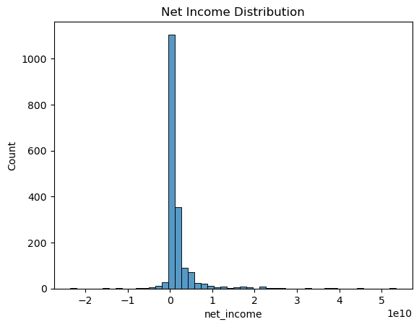
Figure 2. Silhouette Scores — strong structure up to k = 4.
A PCA visualization confirmed that these clusters separate clearly, meaning the groups represent real differences rather than noise.
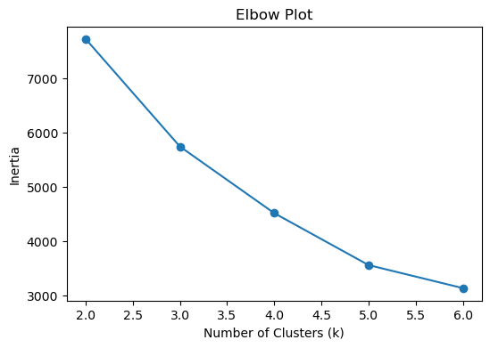
Figure 3. PCA visualization of the four clusters.

Predictive Modeling
A binary target variable labeled firms as high‑margin (above median). Random Forest achieved perfect accuracy due to strong relationships in the data. Including the cluster label improved model performance, showing that unsupervised feature discovery added value.

Business Insights & Recommendations
1. Cluster 1 (high‑revenue, high‑margin firms) represents the strongest performers—ideal for long‑term partnerships.
2. Cluster 0 contains low‑revenue and low‑profit firms; operational improvements or restructuring may be needed.
3. Clusters 2 and 3 show moderate profitability and stable financials—growth initiatives could increase returns.
4. Consistent margin differences across clusters suggest opportunities for pricing strategy adjustments.

Limitations & Next Steps
The dataset may contain outliers, and results may vary across industries. Future work should include:
• Time‑series analysis
• Industry‑specific segmentation
• Additional non‑financial features

